# 1 规划模块的整体架构

L3自动驾驶系统包含多种感知传感器，和定位地图服务，需要底盘和动力系统保证最终执行。在整个应用层中，包含感知模块PER，地图模块MAP，定位和自车状态模块LOC+Odometer，规划模块planning，功能模块FCT ，运动控制模块controler。感知PER提供动态障碍物，车道线等环境信息，

定位模块，提供自车绝对定位和车辆运动状态信息，如经纬度，车速等;

地图MAP模块，提高高速、高架的车道拓扑信息，当高速导航自动驾驶功能开启，FCT模块会发送功能激活请求给planning模块，planning 根据地图和当前自车定位规划出到达目的地的最佳路线，结合实时感知信息，planning 模块会评估最佳运动行为，规划出最佳轨迹，发送给运动模型模块controller做运动执行。

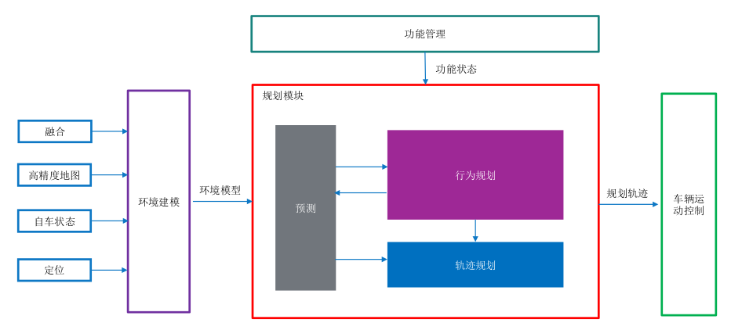

planning模块内部划分为环境建模，预测，行为规划，轨迹规划。

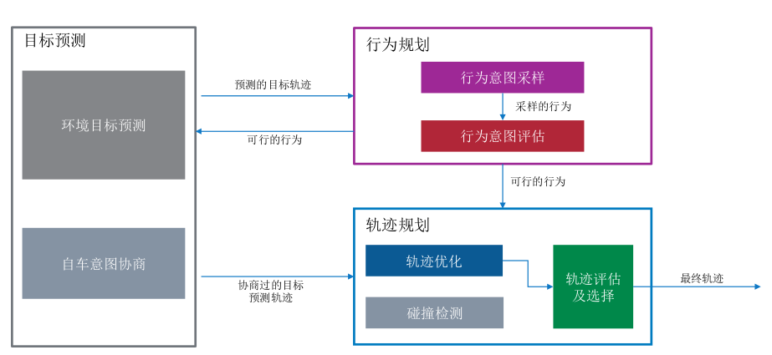

# 2 规划模块子系统

## 2.1 环境建模

### 2.1.1 障碍物感知

The perception information mainly includes:

- dynamic world

- static world

- free space, indicates the space could be traversed by vehicles

- visible grid map, the grid value indicates whether the grid could be detected by any sensor

### 2.1.2 道路拓扑感知

The environment model shall provide the following information of road topology:

- global routing info

- road segment list

- lane net list

- road edge list

- stop line list

- cross walk list

- traffic sign list

- traffic light list

- parking slot list

- reference line

- keep clear region list

- intersection

### 2.1.3 高精地图

The environment model shall provide function to search and extract map information including:

- lane net

- lane relation

- crossing walk

- stop point(or stop line)

### 2.1.4 高精定位

The environment model shall provide the following localization information:

- time stamp(UTC)

- global pose in WGS84 coordinate

- pose (x,y,z) and their variance in local coordinate frame

- linear speed(vx, vy, vy) and their variance in ego vehicle frame

- linear acceleration(ax, ay, az) and their variance in ego vehicle frame

- euler angle(roll, pitch,yaw ) and their variance in local coordinate frame

- angular velocity(rollrate, pitchrate, yawrate ) in ego vehicle frame

- localization status(ok, not ok)

## 2.2 预测模块

### 2.2.1 轨迹预测

The prediction module provides the estimated future info of objects.

Prediction module shall provide trajectory prediction for cyclist for future p_MAX_pred_time seconds with each step being p_pred_step_time s. Predicted information shall include:

- position;

- velocity;

- orientation;

### 2.2.2 意图预测

Prediction module shall provide intent prediction for vehicle. 预测交通参与者可能会执行的行为

Intent shall include:

- lane keeping

- left lane change

- right lane change

- left turn

- right turn

- U turn

## 2.3 功能管理模块

The function manager shall output the following evaluations for the supported behaviors requested by FCT:

- Assessment, reflecting confidence that its model assumptions are fulfilled and that it can assess the current situation and behavior accurately;

- Driver intention match, implement the driver's agreement with the behavior;

- Necessity, which can be summarized as the collision probability of ego vehicle with an object (pedestrian, cyclist, vehicle, road side boundary) or regulation (lane lines) if the course of the ego vehicle is not altered.

- Collision Probability, which is interpreted as the collision probability conditioned on the system reaction being executed continuously.

- Whether valid and recommended (m_reactionPattern.isValid or m_isReactionPatternValid)

The function manager shall at least output the intention values for the following behaviors requested by FCT:

- ALD_LongLat

- ALD_Long

- ALC_Left_LongLat

- ALC_Right_LongLat

- E2E_highway

- E2E_urban

## 2.4 行为规划

**Driving scenarios，行为规划模块提供了多种驾驶场景的行为**

行为规划：

环境坐标转化：转换为frenet坐标系

搜索算法：A*

曲线选择：cost计算

The behavior planner is a module which provides the behavior level info for trajectory planning module as input.

The behavior planner shall consider multiple trajectories predicted by prediction module to make a decision.

The behavior planner shall provide required inputs for the trajectory planner.

### 2.4.1 Adaptive Cruise Control

**2.4.1.1 The feature (Adaptive) Cruise Control ((A)CC) extends the functionality of the conventional cruise control.**

**Besides holding a speed set by the driver, the feature can automatically adapt the velocity in order to keep a safe distance to driving vehicles, when in Adaptive Cruise Control Mode.**

**The security distance is chosen by the driver in form of a time-gap. If the preceding vehicle is not detected any more, the Adaptive Cruise Control feature returns to the driver desired speed and behaves like conventional cruise control.**

自适应巡航控制（ACC）扩展了传统巡航控制的功能。除了保持驾驶员设置的速度外，该功能还可以自动调整速度，以保持与前车的安全距离，当处于自适应巡航控制模式时。安全距离由驾驶员以时间间隔的形式选择。如果不再检测到前车，则自适应巡航控制功能会返回到驾驶员期望的速度，并像传统巡航控制一样运行。

#### 2.4.2.1.1 Free Cruise

2.4.1.1 The behavior planner shall detect potential target objects when ACC is requested by FCT including:

1. Leading object

2. 2nd leading object

3. Leading object on the left adjacent lane

4. Leading object on the right adjacent lane

5. ACC selected object

The behavior planner shall consider stationary vehicles which are in the path of the ego vehicle for speeds of ego of maximum #p_ACC_MaxSpeedForStaticObject.

The behavior planner shall distinguish the potential target object as cars, trucks, motor cycle, pedestrians and stationary objects according to fusion results.

The behavior planner shall consider targets with relative velocity between [VALUE 1] m/s and [VALUE 2] m/s.

Non-stationary objects moving in the opposite direction shall not be considered as target object.

Objects moving in the opposite direction is defined as:

• Vx of the object is negative.

• Absolute value of Vy of the object is less than #p_ACC_OnComingObj_Vy_thresld.

The TargetDetectionRegionOfInterest shall be defined as

• Region of Interest longitudinal: 0.2m - 180m long from VehicleCoordinateSystemOrigin

• Region of Interest lateral: +/-8m wide from VehicleCoordinateSystemOrigin.

• Field of view longitudinal:

• up to 25m: +/- 45°

• up to 60m: +/- 20°

• up to 110m: +/- 10°

• up to 180m: +/- 5°

• Field of view left corner: 150°

• Field of view right corner: 150°

If there is more than one forward vehicle on straight roads and in steady-state curves, the forward vehicle in the subject vehicle's path shall be selected for ACC control in typical ACC situations.

If NO line markings are available from environment model, the behavior planner shall determine a virtual lane.

The behavior planner shall associate confirmed target objects with the identified lanes.

The behavior planner shall select the target object from the list of possible target objects.

Note: List of possible target objects contains possible targets in the ego lane or in the neighbouring lanes.

Possible target objects shall be selected from:

• ForwardTarget: Closest target object in front of the ego vehicle in the trajectory.

• AheadTarget: Second closest target object in front of the ego vehicle in the trajectory.

• FrontLeftTarget: Closest target on the left side of the ego vehicle's trajectory.

• FrontRightTarget: Closest target on the right side of the ego vehicle's trajectory.

• StoppedTarget: Target object which was detected moving before and now come to stationary in the ego vehicle's trajectory path.

• StationaryInPathVehicle: Stationary target object(object which is not seen as moving by the system) in the ego vehicle's trajectory path.

The environment model shall provide the following general information of each dynamic object in local coordinate frame:

- ID

- object classification

- object classification confidence

- reference position and variance

- reference position type

- lateral speed, longitudinal speed, lateral acceleration,longitudinal acceleration,orientation and their variance

- associated agent information

- object shape, represented by polygon

- bounding box, contains length, width, height, heading and center point

- history trajectory within p_History_Traj_Duration s

- two associated lane ID and probability

- contribute sensor

- state of static, contains: moving, stopped, stationary, unknown

- exist probability

- moving direction

当自适应巡航（ACC）由FCT请求时，行为规划应该检测到潜在的目标对象，包括：

1. 前方对象
2. 第二前方对象
3. 左侧相邻车道的前方对象
4. 右侧相邻车道的前方对象
5. ACC选择的对象

行为规划应考虑在自车路径上的静止车辆，对于自车速度不超过最大速度 #p_ACC_MaxSpeedForStaticObject。

#### 2.4.2.1.2 Approaching

#### 2.4.2.1.3 Approaching VRUs (none static)

#### 2.4.2.1.4 Vehicle Following

#### 2.4.2.1.5 Drive off

#### 2.4.2.1.6 Intruder detection - OBSOLETE

#### 2.4.2.1.7 Stopping

#### 2.4.2.1.8 Approaching Stationary Vehicle

#### 2.4.2.1.9 Preceding Vehicle Cut-in

#### 2.4.2.1.10 Preceding Vehicle Cut-out

#### 2.4.2.1.11 Curve Driving

#### 2.4.2.1.12 Reaction on non-relevant objects

#### 2.4.2.1.13 Take over request

### 2.4.2 In-lane Driving (TJA/ICA)

#### 2.4.2.2.1 Without preceding vehicle

#### 2.4.2.2.2 With preceding vehicle

##### 1.Line available

单线，和双线

If lane boundaries on both sides of ego lane are not determined with enough confidence and ego speed is lower than 60kph, the behavior planner shall propose a behavior to let ego imitate the preceding vehicle's lateral movement.

If lane boundaries on both sides of ego lane are not determined with enough confidence and ego speed is higher than 60kph, the behavior planner shall follow the scenario same to that without preceding vehicle.

##### 2.No Line Available (Preceding Vehicle Turns)

When TJA/ICA is activated by FCT and and ego is imitating a preceding vehicle's lateral movement, if another road user cut-in between preceding vehicle and ego vehicle, the behavior planner shall not react to the cut in vehicle until the target longitudinal object swaps to the cut in vehicle

When TJA/ICA is activated by FCT and and ego is imitating a preceding vehicle's lateral movement, if preceding vehicle cuts out, the behavior planner shall not follow the preceding vehicle cut-out and propose a Self-assessment intention value lower than p_lat_active_assessment_thres.

When TJA/ICA is activated by FCT and ego lane splits ahead in the environment model and the lane boundaries could not be determined with enough confidence on both sides, the behavior planner shall propose a behavior to guide ego vehicle to the lane that the target vehicle enters.

### 2.4.3 Automatic Lane Change (ALC)

The behavior planner shall propose a behavior to let ego complete lane change manoeuvre and the ego vehicle front tire shall touch the line between the origin lane and target lane after 2.0 seconds and not later than 4.0 seconds after the starting of lateral movement towards target corridor.

background: UN ECE-R79 5.6.4.4.

A "Lane Change Procedure" starts when the direction indicator lamps are activated by a deliberate action of the driver and ends when the direction indicator lamps are deactivated. It comprises the following operations:

(a) Activation of the direction indicator lamps by a deliberate action of the driver;

(b) Lateral movement of the vehicle towards the lane boundary;

(c) Lane Change Manoeuvre;

(d) Resumption of the lane keeping function

(e) Deactivation of direction indicator lamps;

### 2.4.4 End to End

#### 1 Lane following

The Behavior Planner shall working properly to drive safely, efficiently and comfortably under Lane-Following status in below scenarios:

- Stop & Go traffic situation;

- Driving in lane with vulnerable road users;

- Driving in lane with crosswalk in front;

- Static objects in the ego driving lane in front;

- Other vehicle cutin into ego driving lane;

- Neighbor lane with parked vehicles, vehicles parking out, parked vehicles with door open;

- Passing through truck driving on neighbor lane;

- Driving in lane in tunnel;

- Entering new speed limit zone indicated by new speed limit sign;

- Driving in big curvature lane;

#### 2 Lane change procedure

The behavior planner shall provide the target lane (whether turn to left lane or right lane) and target position (relative position with other traffic participants in target lane) for informing the driver's confirmation if there is a feasible gap for performing the lane change.

Note: Informing driver to confirm only when driver has set ego vehicle in "Active confirmation" mode.

The behavior planner shall seperate the lane change procedure into the following phases and determine which phase ego is currently in:

T0: Activation of the direction indicator lamps by a deliberate action of the driver or system;

T1: Lateral movement of the vehicle towards the lane boundary;

T2: Lane change maneuver start;

T3: Lane change maneuver end;

T4: Resumption of the lane keeping function and deactivation of direction indicator lamp.

The behavior planner shall provide the below phases for a lane change:

• Lane change direction indicator active; (T0)

• Lane change lateral move start; (T1)

• Lane change maneuver start; (T2)

• Lane change maneuver end; (T3)

• Lane change finished; (T4)

• Lane change cancel by driver (before T2)

• Lane change abort by system (before T2);

#### 3 Lane Merge/Split

End to End supports general lane split/merge use cases encountered on the driving route.

- In the case of lane merge, ego vehicle will merge with other traffic participants, considering safety/avoidance of potential collision.(汇入)

- In the case of lane split, ego vehicle will choose the target lane according to navigation information.（汇出）

#### 4 Urban E2E Intersection

#### 5 Urban E2E Roundabout

#### 6 Safe Stop

The behavior planner shall propose a safe stop behavior to let ego stop with deceleration lower than p_u_Safestop_Axlimit if safe stop is requested by FCT.

#### 8 Intelligent Speed adaption(ISA)

The ISA (Intelligent Speed Adaption) function is a subfeature of highway and urban E2E. It shall adjust ego vehicle target speed by considering the following conditions/scenario:

1. speed limit from map lane segment;

2. speed limit from traffic sign

3. upcoming road/lane curve, here the curve means the curve radius is less than #p_HW_ISA_MaxRadius;

4. the ramp without a specific speed limitation and ego vehicle will exit the highway by the ramp

5. bad weather

6. upcoming road/lane slope too big (Not applicable to Highway / expressway scenario as the main concern for slope is potential poor visibility of oncoming vehicle in neighboring lane. In Highway/expressway scenario, 2 driving directions will be seperated by physical barrier )

7. upcoming speed bump (same behavior in ACC feature, not elaborated in E2E requirement)

Note:the lane segment speed limit from map is only used for activation of E2E, the traffic sign related speed limit could be not available while E2E gets activated.

#### 7 Intelligent evasion

IntEva helps ego vehicle to keep certain lateral distance when passing through truck or bus on the adjacent lane. It makes the driver feel more comfortable and reduces the danger feeling.

The intelligent evasion procedure in E2E feature is defined as follows:

T1: IntEva activation conditions fulfilled, ego starts lateral movement to evade the truck

T2: Ego reaches and keeps the target lateral movement distance against the truck

T3: Ego finishes IntEva and start to return to lane center driving.

T4: Ego resume lane center driving.

The behavior planner shall propose a behavior to evade from truck if all the follwing conditions are met:

IntEva shall only be activated when all the below conditons are fulfilled:

1. Highway E2E or UrbanE2E or TJAICA is active;

2. Ego vehicle shall have the minimum lateral distance of #p_IntEva_minDist2RoadEdge to the road edge when in the most left or most right lane;

3. It's observed that no vehicle(truck or bus or big vehicle) will be within the defined safe longitudinal distance on the opposite adjacent lane in [#P_IntEva_SafeDist_Behind,#P_IntEva_SafeDist_Ahead] ; (adacent traffic incl. all types of 4 wheelers & motocycles)

4. Ego lane both lane marking exist for over #P_IntEva_ConfiLaneAhead_time time longitudinally ahead ;

5. Ego lane width is more than #P_IntEva_EnableLaneWidth;

6. Ego lane radius is larger than #P_IntEva_EnableLaneCurveRadius;

7. Ego speed is larger than #P_IntEva_EnableEgoSpeed;

8. After the passing through phase begins, the longitudinal distance between target truck and ego is less than #P_IntEva_IntEvaStart_TTC*Vego;

9. The initial lateral distance between ego vehicle and target truck is less than #P_IntEva_MaxEnableLatDist2Truck;

10. The IntEva target is big vehicle, truck or bus(see the truck definition), not other kinds of transportations;

11. Drive's hands are detected on the steering wheel.

12.(Vego - Vtargettruck) > 5kph

#### 9 Side Pass

Side pass is a lateral bahavior aimed to evade small blockage in ego lane and consists of two sub-behavior:

- Bypass, ego vehicle will borrow adjacent lane

- In-lane nudge, ego vehicle will keep in ego lane during lateral movement.

#### 10 Driver override

## 2.5 运动规划

路径规划：

路经编码：贝赛尔曲线

动态目标避障：

The trajectory planner receives the environment model info and behavior planning result, plans a trajectory for ego vehicle to follow

The trajectory planner shall plan a furture trajectory for ego vehicle for p_max_plan_horizon s

**Remark:p_max_plan_horizon=8s**

基础信息：

Coordinate introduction:

- Local Coordinate Frame

This coordinate frame uses the initial position when turned on as origin point, and the vehicle direction as axis orientation, updates with odometry accumulation and localization delta.

- Frenet Coordinate Frame

This cooridnate frame is built based on a reference line, uses the distance along the ref line as S direction, the distance in normal direction to the ref line point as L direction.

- Ego Vehicle Coordinate Frame

This coordinate frame origin is within the center point of the rear axle of the ego vehicle. Its x-axis points towards the positive driving direction. The y-axis towards the left side and the z-axis out of the plane of drawing.

The environment model shall provide time synchronization to:

- dynamic object

- static world

- odometry

- localization information.

**3 Planning Non-Functional Requiremnets**

**4 Planning Safety Requirements**

L3功能开发，基于现有的高速领航辅助功能进行裁剪,降级车速，禁掉变道功能， 禁掉脱手检测，限制功能ODD等

适配冗余底盘等矩阵

开发DSSAD功能(基于GBT自动驾驶数据记录系统-20220730讨论稿)

开发必要的降级策略